|  |
| --- |
| Project : SPARQL Queries |

|  |
| --- |
| Web Datamining & Semantics |

|  |  |
| --- | --- |
| Emine BOUCHIBA  Yassine CHENIK |  |



Table des matières

Launching Fuseki2

Query 14

Query 25

Query 36

Query 47

Query 58

Proposal Query 19

Proposal Query 211

Proposal Query 313

Proposal Query 414

Proposal Query 515

|  |
| --- |
| Launching Fuseki |

1. In Windows Command Line :

cd C:/apache-jena-fuseki-4.7.0

fuseki-server --update --mem /ds

1. On Internet :

We should go to this link : http://localhost:3030

1. In Fuseki Interface :

* We clicked on the « Manage data » button :

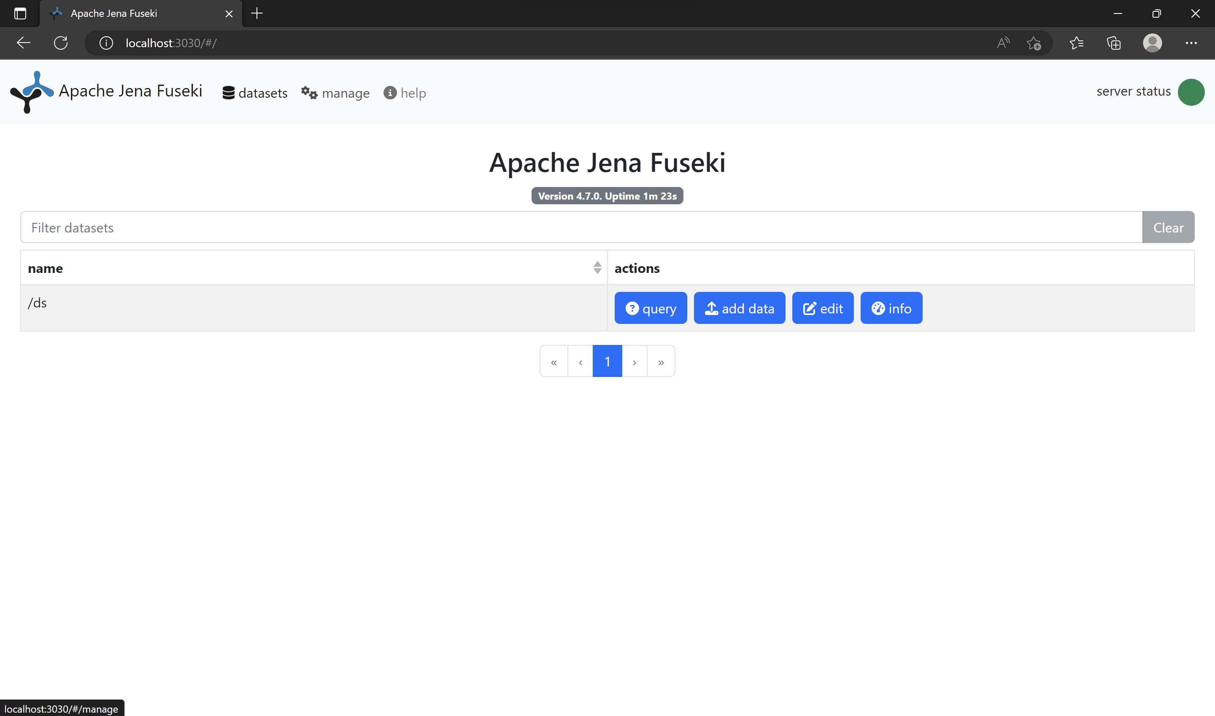

* Then we clicked on the « New Dataset » section and on « Persistent » :

|  |
| --- |
| Launching Fuseki |

* Then we added our Ontology :

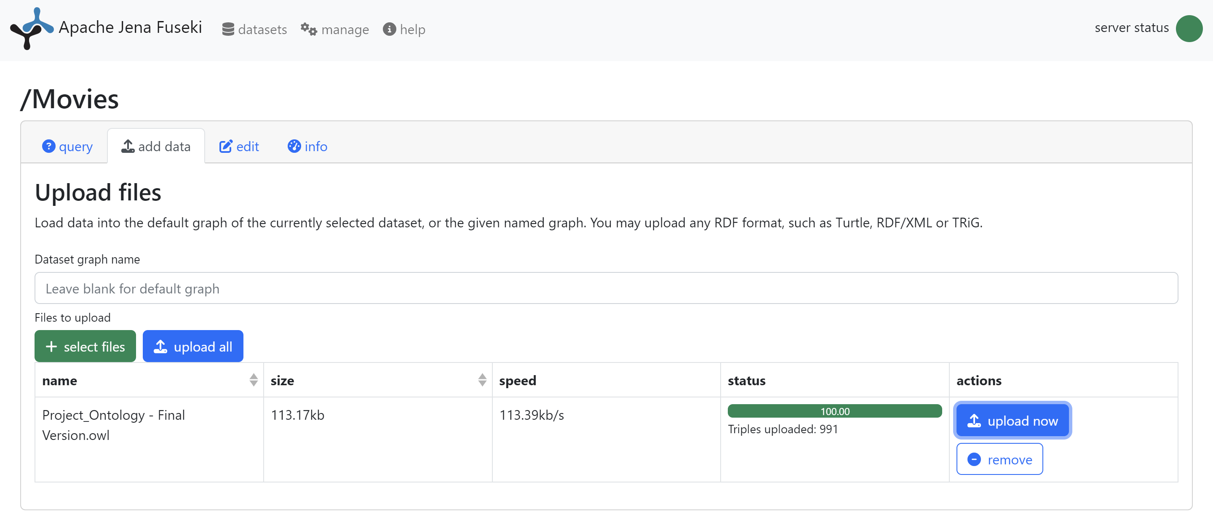

* At this step, we were able to make queries :

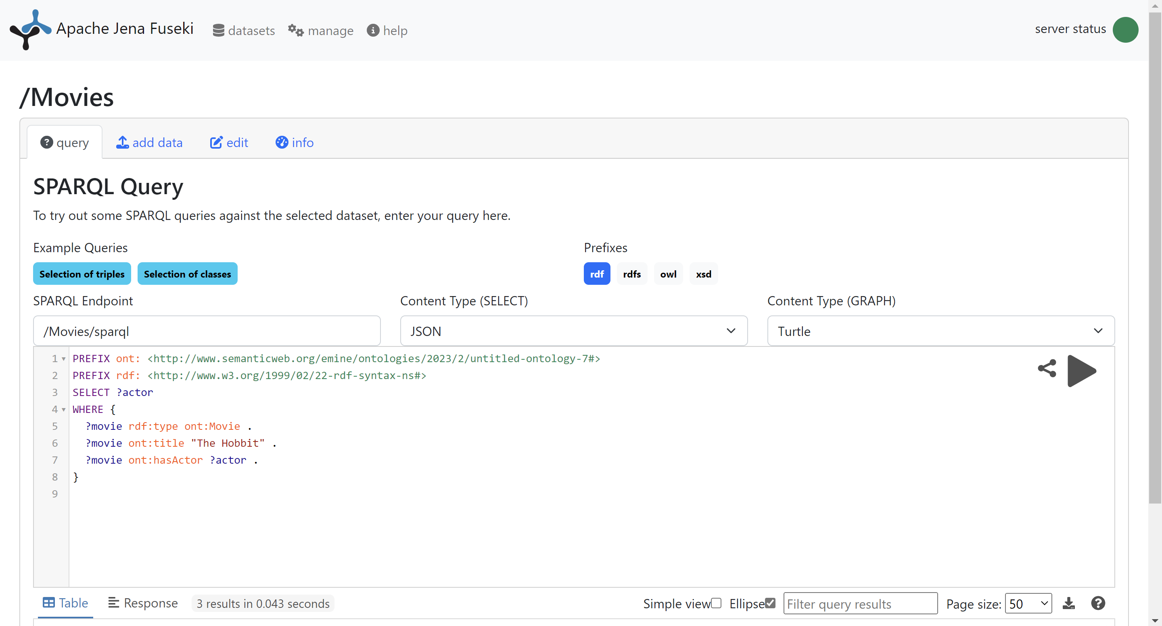

|  |
| --- |
| Query 1 |

* List the instances of the class Actor
* Query :

PREFIX rdf: <http://www.w3.org/1999/02/22-rdf-syntax-ns#>

PREFIX : <http://www.semanticweb.org/emine/ontologies/2023/2/untitled-ontology-7#>

SELECT ?actor

WHERE {

?actor rdf:type :Actor

}

* *Output :*

|  |
| --- |
| Query 2 |

* List the name of all Thriller movies. For each one, display its director.
* Query :

PREFIX rdf: <http://www.w3.org/1999/02/22-rdf-syntax-ns#>

PREFIX ont: <http://www.semanticweb.org/emine/ontologies/2023/2/untitled-ontology-7#>

SELECT ?movie ?director_name

WHERE {

?movie ont:hasGenre ont:Thriller .

?movie ont:hasDirector ?director .

?director ont:name ?director_name .

}

* *Output :*

|  |
| --- |
| Query 3 |

* List the name of all Crime Thriller movies.
* Query :

PREFIX rdf: <http://www.w3.org/1999/02/22-rdf-syntax-ns#>

PREFIX ont: <http://www.semanticweb.org/emine/ontologies/2023/2/untitled-ontology-7#>

SELECT ?movie_name

WHERE {

?movie rdf:type ont:Movie .

?movie ont:hasGenre ont:Thriller .

?movie ont:hasGenre ont:Crime .

?movie ont:title ?movie_name .

}

* *Output :*

|  |
| --- |
| Query 4 |

* List the name of Actors older than 51 years.
* Query :

PREFIX rdf: <http://www.w3.org/1999/02/22-rdf-syntax-ns#>

PREFIX ont: <http://www.semanticweb.org/emine/ontologies/2023/2/untitled-ontology-7#>

SELECT ?actor_name

WHERE {

?actor rdf:type ont:Actor .

?actor ont:age ?age .

FILTER(?age > 51) .

?actor ont:name ?actor_name .

}

* *Output :*

|  |
| --- |
| Query 5 |

* List of movies that are played in theater for a specific day and where and until when
* Query :

PREFIX rdf: <http://www.w3.org/1999/02/22-rdf-syntax-ns#>

PREFIX ont: <http://www.semanticweb.org/emine/ontologies/2023/2/untitled-ontology-7#>

SELECT ?movie_title ?theater_name ?from_date ?to_date

WHERE {

?movie rdf:type ont:Movie .

?movie ont:title ?movie_title .

?movie ont:year 2016 .

?theater rdf:type ont:Theater .

?theater ont:isPlaying ?movie .

?theater ont:theater_name ?theater_name .

?movie ont:from_date ?from_date .

?movie ont:to_date ?to_date .

}

* *Output :*

|  |
| --- |
| Proposal Query 1 |

* Query that contains at least 2 Optional Graph Patterns
* Query :

PREFIX rdf: <http://www.w3.org/1999/02/22-rdf-syntax-ns#>

PREFIX ont: <http://www.semanticweb.org/emine/ontologies/2023/2/untitled-ontology-7#>

SELECT ?movie_title ?director_name ?writer_name ?actor_name

WHERE {

?movie rdf:type ont:Movie .

?movie ont:title ?movie_title .

OPTIONAL {

?movie ont:hasActor ?actor .

?actor ont:name ?actor_name .

}

OPTIONAL {

?movie ont:hasDirector ?director .

?director ont:name ?director_name .

}

OPTIONAL {

?movie ont:hasWriter ?writer .

?writer ont:name ?writer_name .

}

}

|  |
| --- |
| Proposal Query 1 |

* *Output :*

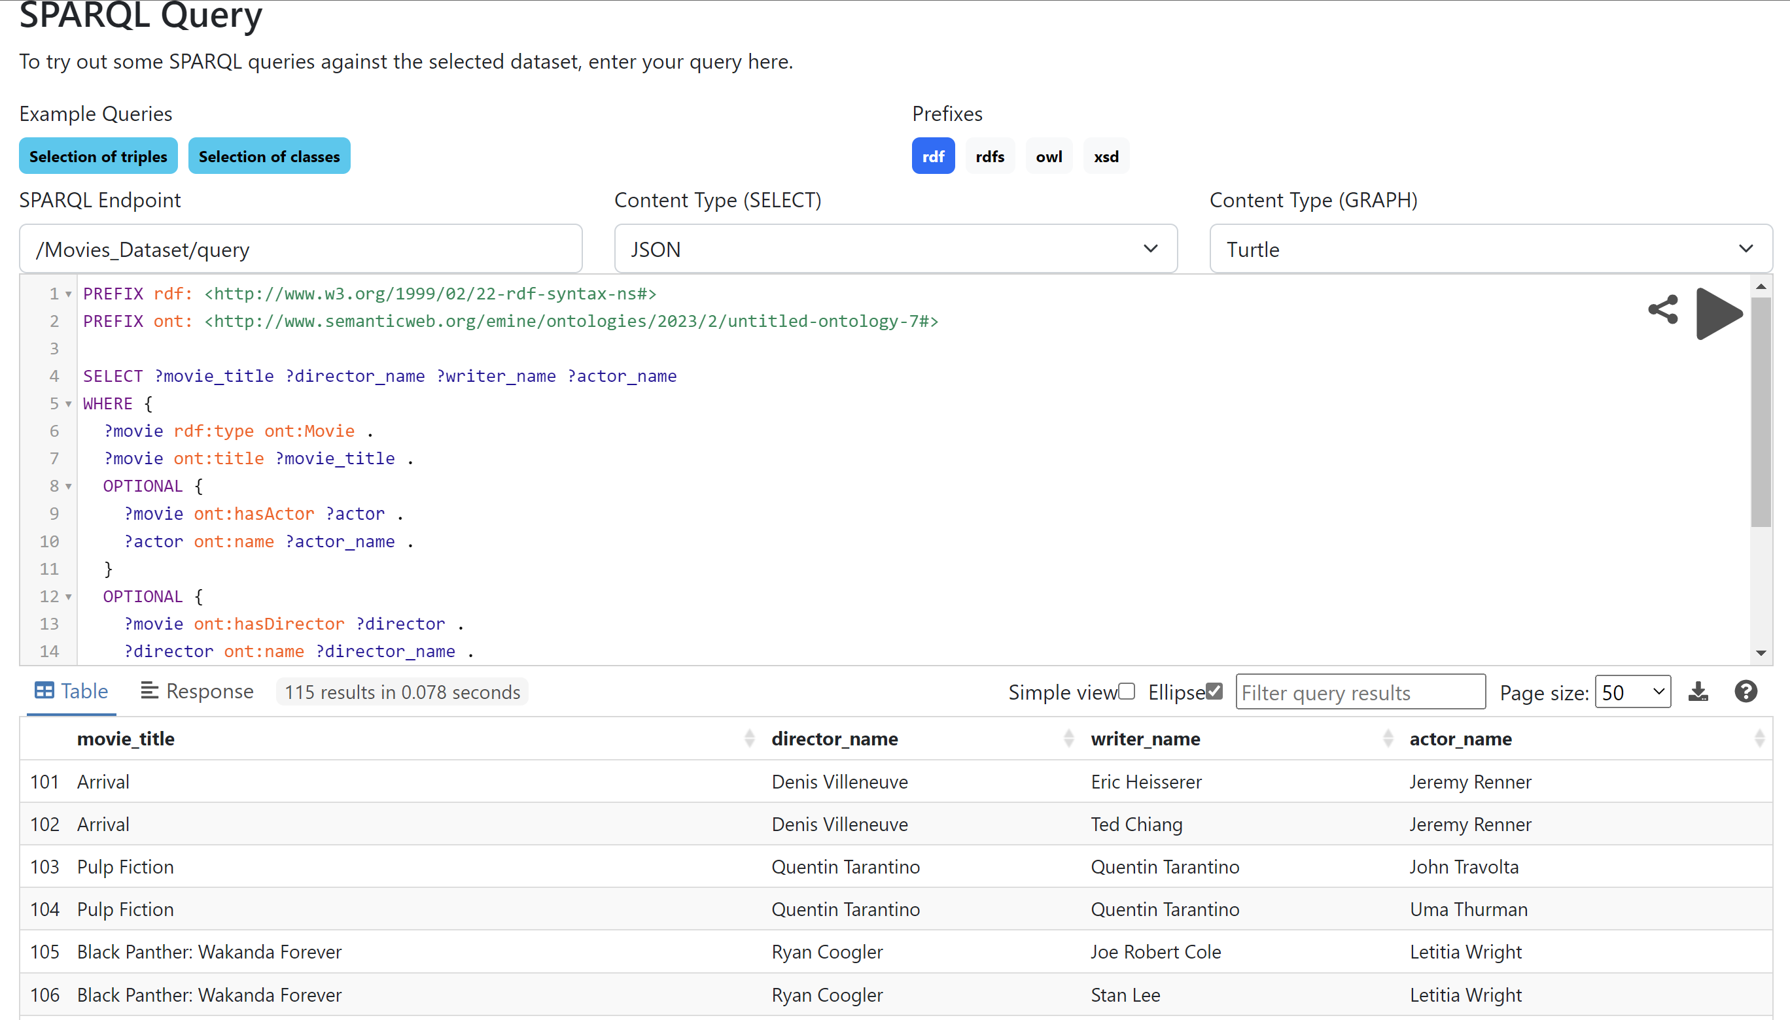

|  |
| --- |
| Proposal Query 2 |

* Query that contains at least 2 alternatives and conjunctions
* Query :

PREFIX rdf: <http://www.w3.org/1999/02/22-rdf-syntax-ns#>

PREFIX ont: <http://www.semanticweb.org/emine/ontologies/2023/2/untitled-ontology-7#>

SELECT ?title ?actor ?director ?genre

WHERE {

{

?movie rdf:type ont:Movie .

?movie ont:title ?title .

?movie ont:hasGenre ?genre .

FILTER (?genre = ont:Thriller || ?genre = ont:Horror)

?movie ont:hasActor ?actor .

?movie ont:hasDirector ?director .

?director ont:name ?director_name .

?actor ont:name ?actor_name .

FILTER (?director_name = "Quentin Tarantino" && ?actor_name = "Uma Thurman")

}

UNION

{

?movie rdf:type ont:Movie .

?movie ont:title ?title .

?movie ont:hasGenre ont:Comedy .

?movie ont:hasActor ?actor .

?movie ont:hasDirector ?director .

?director ont:name ?director_name .

?actor ont:name ?actor_name .

FILTER (?director_name = "Quentin Tarantino" && ?actor_name = "Uma Thurman")

|  |
| --- |
| Proposal Query 2 |

}

}

|  |
| --- |
| Proposal Query 2 |

* *Output :*

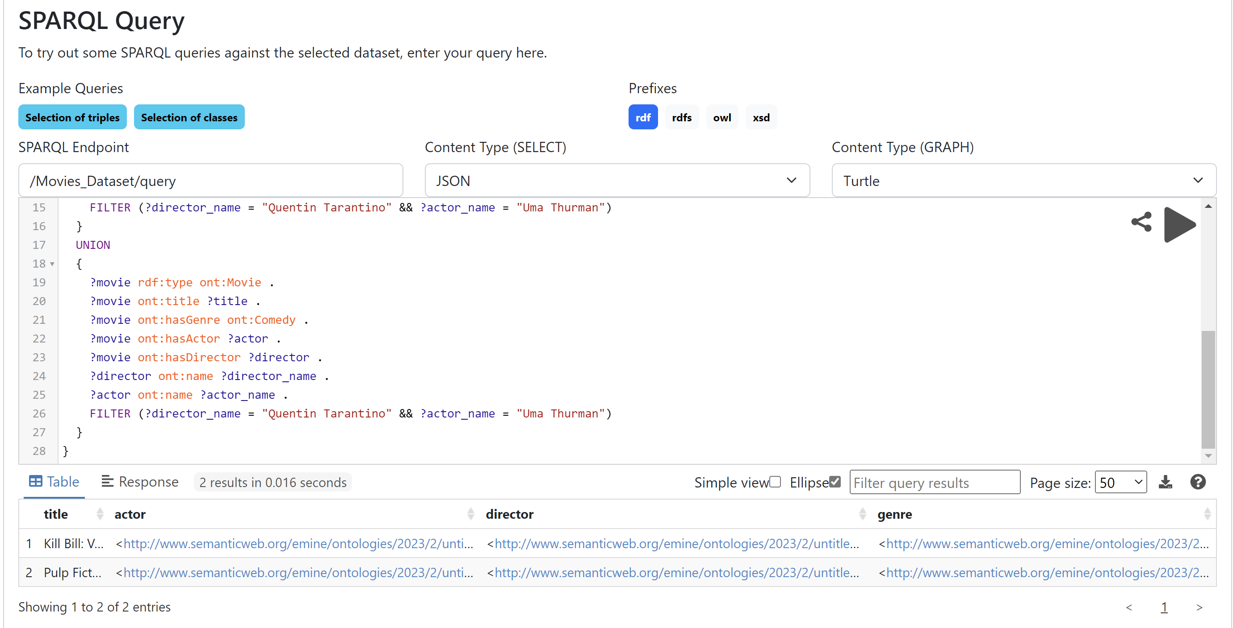

|  |
| --- |
| Proposal Query 3 |

* Query that contains a CONSTRUCT query form
* Query :

PREFIX rdf: <http://www.w3.org/1999/02/22-rdf-syntax-ns#>

PREFIX ont: <http://www.semanticweb.org/emine/ontologies/2023/2/untitled-ontology-7#>

CONSTRUCT {

?actor ont:isActorOf ?movie .

?movie ont:hasActor ?actor .

}

WHERE {

?movie rdf:type ont:Movie .

?movie ont:title "Sicario" .

?movie ont:hasActor ?actor .

}

* *Output :*

|  |
| --- |
| Proposal Query 4 |

* Query that contains an ASK query form
* Query :

PREFIX rdf: <http://www.w3.org/1999/02/22-rdf-syntax-ns#>

PREFIX ont: <http://www.semanticweb.org/emine/ontologies/2023/2/untitled-ontology-7#>

ASK {

?movie rdf:type ont:Movie .

?movie ont:title "Sicario" .

?movie ont:hasGenre ont:Action .

}

* *Output :*

|  |
| --- |
| Proposal Query 5 |

* Query that contains a DESCRIBE query form
* Query :

PREFIX rdf: <http://www.w3.org/1999/02/22-rdf-syntax-ns#>

PREFIX ont: <http://www.semanticweb.org/emine/ontologies/2023/2/untitled-ontology-7#>

DESCRIBE ?movie

WHERE {

?movie rdf:type ont:Movie .

?movie ont:title "The Avengers" .

}

* *Output :*

